Map Activities

These activities are all linked to drawing and using maps, and are inspired by the section on James Millerd’s map of Bristol in The Bristol Story: a graphic and (mostly) true story of the greatest city in the world.

Younger and less confident readers will be using a simplified version of the book and a separate set of activity sheets, but some of the mapping activities here might also be suitable for them.

Directions

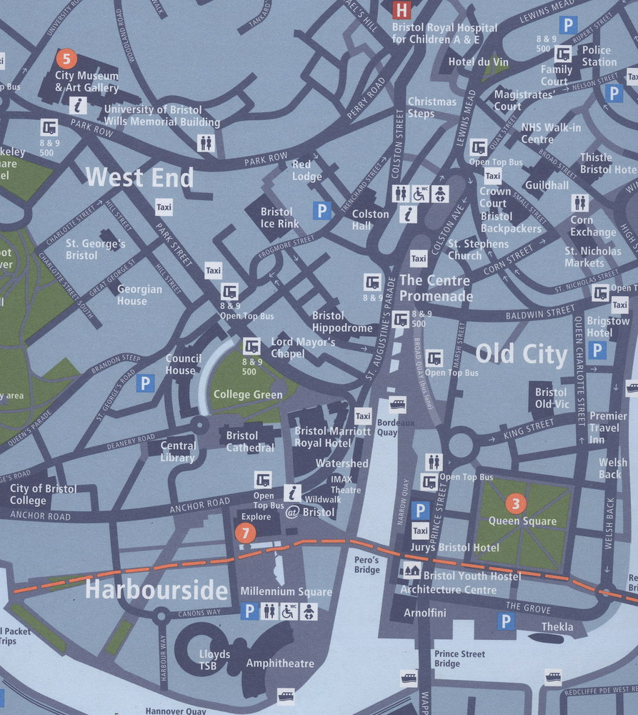

Imagine you are in the centre of Bristol. When you are crossing Prince Street Bridge, towards the Arnolfini, a man asks you how he can get to the City Museum on foot. Work out the directions from the map above, giving the man as many details as possible. What useful information is included in the map? What other information would it be helpful to have when you give directions?

You can get free copies of this map from most tourist sites in the city, as well as libraries, hotels and other public places.

You can find out how to make a compass in the Science section of the Things 2 Make website at http://www.things2make.com/
The Millerd map

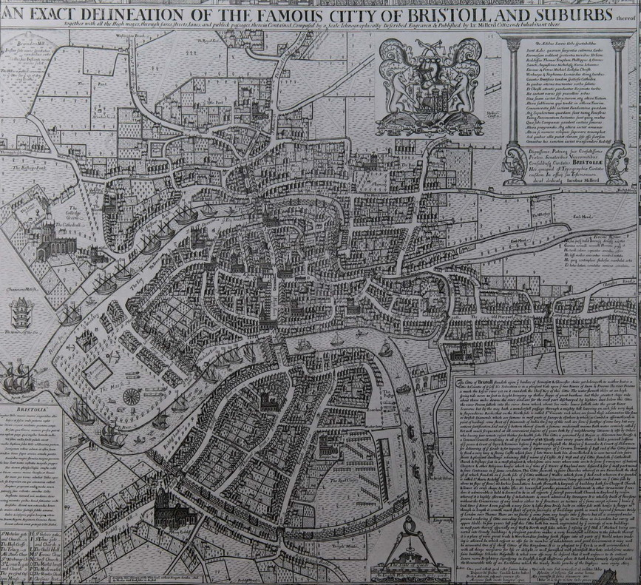

Read the description of the Millerd map in The Bristol Story on pages 111 to 128.

Make a list of all the different places in the city referred to in this section of the book. Search in other books and on the internet to find out what these places look like today and copy the pictures. If you have a chance, go and see the places for yourself and take your own photos or make your own drawings.

Create an illustrated border to go around the old map with modern views of the places that are mentioned in it, drawing a line from each picture to where the place would be on the map.

Try to find out why the places have changed since Millerd’s time.

This map is on display in Bristol’s City Museum and Art Gallery.
Maps through the ages

This picture of the centre of Bristol is over 500 years old. It shows the city walls and gates, and the four main streets – High Street, Wine Street, Corn Street and Broad Street – which used to meet at the High Cross.

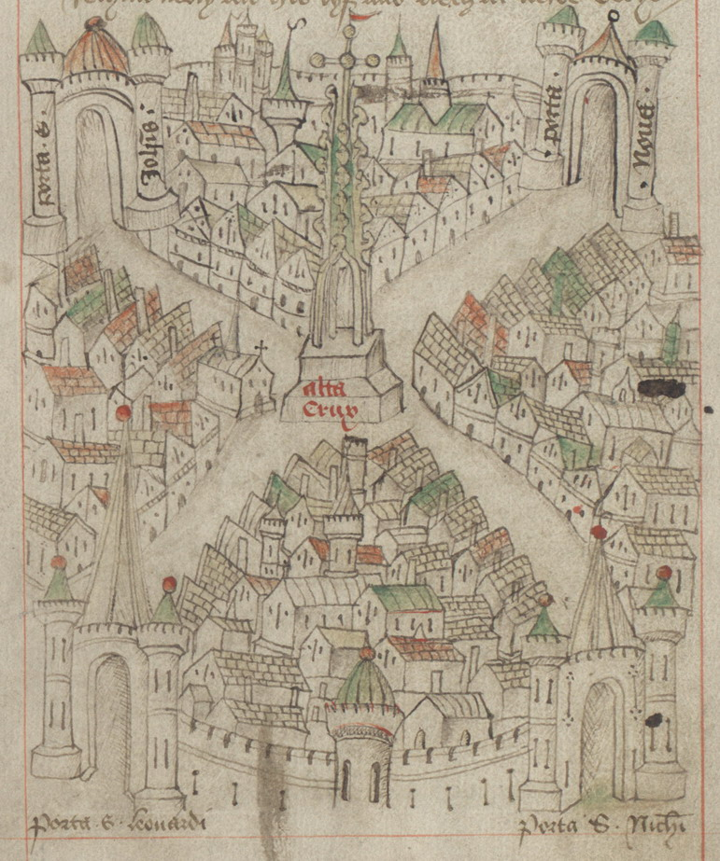

Robert Ricart’s map from The Maire of Bristowe is Kalender (1480-1508) (Bristol Record Office).

Here are details from other maps showing this part of the city. The earliest was made in 1581, the most recent in 2006. Can you find where High Street, Wine Street, Corn Street and Broad Street meet in each of them?

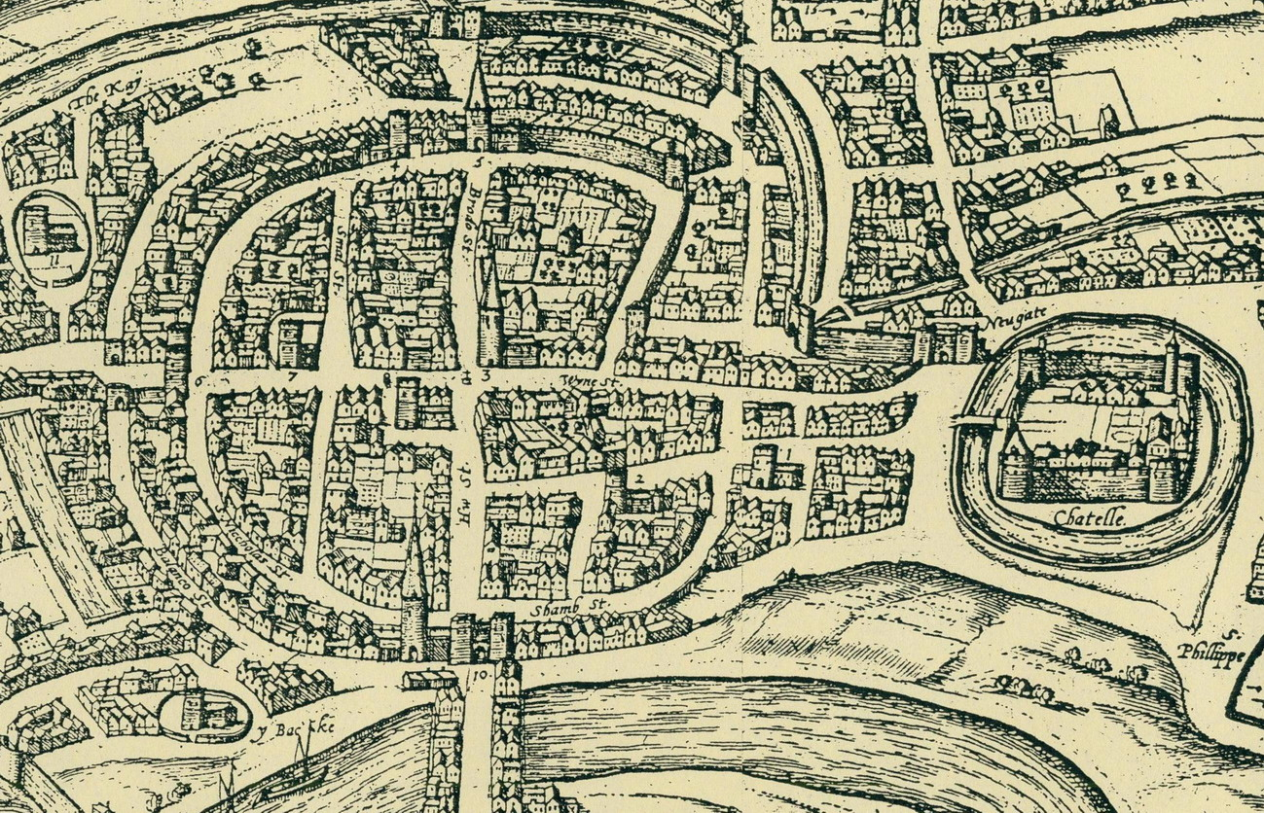

Georgius Hoefnalge’s plan of Brightstowe (1581) (Bristol’s Museums, Galleries and Archives).

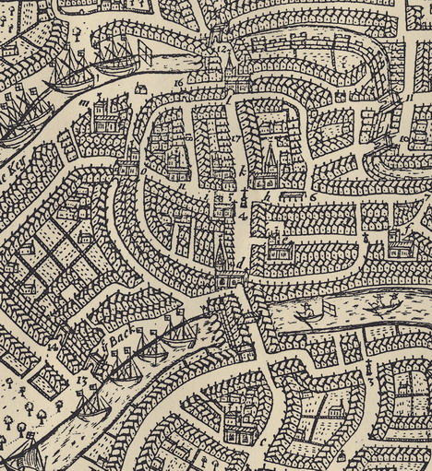

James Millerd’s ‘delineation of the cittie of Bristoll’ (1671) (Bristol Libraries).

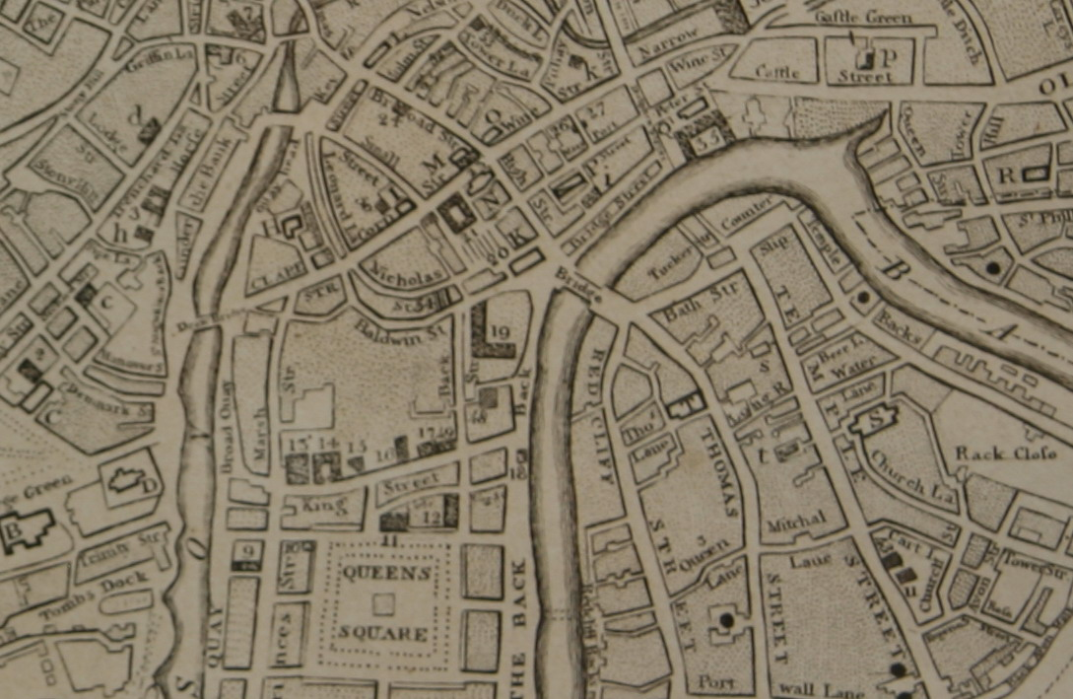

Mathew’s plan of Bristol (1815) (Bristol’s Museums, Galleries and Archives).

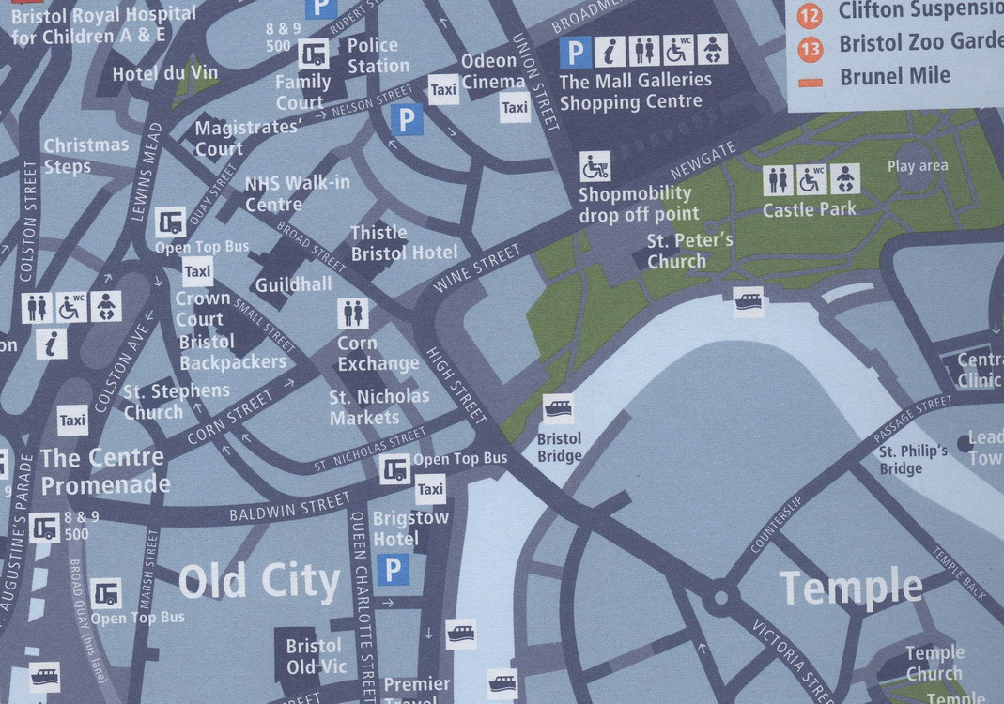

Bristol Legible City walking map of Bristol (2006) (Bristol City Council).

The earliest maps give what is called a bird’s-eye view. It is if you are flying towards the city. You can see how the streets are laid out but you can also see the shape of the buildings facing you. They give a mixture of different perspectives from above and in front. The drawing is not always to scale: look how big the people in the boats are in the Millerd map, for example, compared with the houses. The more recent ones give a more consistent plan view as if you were looking directly from above onto a flat surface.

Which of these different styles of maps do you think looks the most interesting or attractive? Which do you think would be the most practical? Why?

What do these maps tell you about how the design of maps has changed over time? What can you learn from the maps about how Bristol city centre has changed?

You can see more maps of Bristol in the Great Reading Adventure readers’ guide and on the website. If you visit Bristol’s City Museum and Art Gallery, you will find many more maps of Bristol on display. Entry to the museum is free. Your local library will probably have maps showing the area in which you live from different periods of time.

Your Bristol map

Draw maps of the area where you live or go to school using the different styles and viewpoints shown in the previous section. Cover as wide an area as possible around your home or school building.

To plan the layout of your maps:

- Walk around the area, making notes of particular landmarks and how the pattern of streets, buildings and other physical features fits together.
- If you want to draw a more accurate map, measure the angles and distances between different points and then reduce these to a scale that will fit onto a sheet of paper.
- Go to the top of a tall building or a hill and look down to see what the view is like from there.
- Look at photographs and drawings of your area in books or on the internet, including aerial views.
- Adapt existing printed maps of the area, like an Ordnance Survey map of Bristol or an A-Z guide.
- Adapt existing maps on the internet of the area, like Google Maps (maps.google.co.uk/) or Map Quest (www.mapquest.co.uk/mq/home.do/).

The Bristol Legible City (BLC) map uses symbols to show where there are bus and ferry stops, information points, toilets, car parks and taxis. When you draw your version of a BLC map for your area, create your own system of symbols.

Describe a route through one of your maps, like the route described through the Millerd map in The Bristol Story. Say what you can see, hear, feel or smell as you follow the route. Give some historical information about the buildings and the places you pass – like when the buildings were built, how they have changed over time, what used to be there ten or 50 or 100 years ago. Tell anecdotes (stories) about the real or imaginary people you might meet.

Either do this activity as a written piece of work or talk to a partner or to the rest of your group.

To help you in your research:
- Walk the route, making notes of what you experience.
- Look in local history books in the library about what the area used to be like.
- Look at maps of your area of Bristol from different periods of history to see how it has changed.
- Check if your area of Bristol is mentioned in The Bristol Story or on the website for the Great Reading Adventure at www.bristolreads.com
- Look at other sites on the internet that give local information (there are some links you will find on the Great Reading Adventure website).
- Talk to local people who live in the area about what they notice and what they remember about the place.

There are lots of activities and games using maps in the Map Zone of the Ordnance Survey website at mapzone.ordnancesurvey.co.uk/mapzone/games.html

